Cosmos - consistency level
Cosomos TableOperation , CloudTable
Scaling web app - standard it supports , D1 is shared and has no scaling
CDN - edge server - origin server
az webapp deployment - deploys the code from git hub
--repo-url
Event hubs capture to store events in storage account - data is returned in apache avro file format
Rediss - evictin polity and expiratin value for key to remove stale keys
Event grid - better to create separate topics
TableQuery.GenerateFilterCondition("PartitionKey",QueryComparision.Equal,"Smith")
Event Hub - million on items
Azure Web App - AlwayOn - true (for the app not to shutdown)
az keyvault create
az keyvault secret set
Service bus - corelation filter for filtering based on property
Service bus - sql filter - region is not USA and also quantity greater than 100
Service bus - All orders - true filter
Web app - docker - create service plan - --is-linux --sku S1
Web App - for configure docker - we use - az webapp config container set --docker-custom-image-name $dockerHubContainerPath --name $appName --resource-group whizlabs-rg
NotificationClient.CreateClientFromConnectionString
NotificationClient hub --> hub.SendWindowsNativeNotificationAsync()
API management - policy to Inbound (detect user identity , cache look-up) , Outbound (cache store , find and replace) , Error , Parameters
Application insights - Funnel - if most customers are progressing through the entire process
Page load - Impact , how many users return - retention , user flows - how users navigate between the pages

--------------------

API managment inbound and outbound rules
Application insights - to control cost does not exceed pre-set budget - implement adaptive sampling using the Application Insights SDK
Redis cache - IDatabase cache = Connection.GetDatabase() -- cache.KeyDelete("key-name")
Docker - ENTRYPOINT["dotnet","whizlabsApp.dll"] - RUN powershell "whizlabsscript.ps1"
Service Bus - New-AZServiceBusNamespace
Azure CDN - cache every unique url
Resource group - az group create , VM - az vm create , --image win2016datacenter\
AzCopy - to copy resources from one storage to another
Container - permissions to publish images - AcrPush (push & pull images) , AcrPull (only pull access)
Storage account --> Hot - frequently accessed , Cold - less frequent , Archive - rarely accessed
Archive storage --> to read the content from Archive storage , changes the tier of the blog to hot or cool
Redis -- cache.StringSet - to set the string in cache , cache.StringGet - to get the string stored in cache

----------------
Cosmos DB - Bounded Staleness - reads are guaranteed to honor the consistent-prefix gaurantee
"K" version of an items or by "T" time interval
Cosmos - --enable-automatic-failover true
Cosmos DB - --locations "SouthCentralUS=0","NorthCentralUS=1"
Storage - azcopy cp source destination , --recursive=true
Storage - select * from c IN customer.orders where c.price="9.99"
App Plan - Shared plan is not always on
App Plan - Basic is always on
Web App - Enable Application insights - Always On setting

Blob Lease - https://myaccount.blob.core.windows.net/mycontainer/myblob?comp=lease
The Lease Blob operation creates and manages a lock on a blob for write and delete operations. The lock duration can be 15 to 60 seconds, or can be infinite.
CosmosDB - Not a critical application - Eventual

Cosmos DB - Strong - The reads are guaranteed to return the most recent committed version of items
Bounded Staleness - guaranteed to honor the consitent-prefix guantee "K" version , "T" time interval
Session - Within a single client session rads are guaranteed to honor the consitent-prefix . Clients outside of the session performing writes will see eventual consistency
Consistet prefix - Updates that are returned contain some prefix of all the updates , with no gaps . Consistnet prefix consistency level guarantees that reads never see out-of-order writes
Eventual - There no gurantee for reads . In the absence of any further writes , the replicas eventually converge

Stream the logs in web app - az webapp log tail --name "whizlabapp" --resource-group "whizlab-rg" --only-show Errors

Event Grid - Receives failure messages for any resourcs deployed to the Azure subscription -
filter :{ "includedEventTypes" :["Microsoft.Resources.ResourceWriteFailure","Microsoft.Resources.ResourceWriteSuccess"]}

Receives messages whenever objects are added to a specific container in Azure Blob Storage
Subject begins with or ends with - "filter" :{"subjectBegingsWith":"/blobServices/default/containers/mycontainer/log","subjectEndsWith":".jpg"}

Receive messages whenever data fileds in the message has the value of "Organization" - Advanced filters and operators - "advancedFilters" : [{
"operatorType":"NumberGreaterThanOrEquals"
"key":"Data.Key1"
"value":5
},
"operatorType":"StringContains"
"key":"Subject"
"value":["container1","container2"]
}
]

Queue client -- queueClient.SendAsync(message)
Secret - az keyvault secret set

----------------------

Storage account --> ARM templates -- > "name" : "[concat(copyIndex(),'storage',uniqueString(resourceGroup().id))]"
copy : {"name":"createcopy","count":"[parameters('whizlabCount')]"}
tag images : docker tag whizlab-image whizlabregistry.azurecr.io/whizlab-image
Storage filter : "path" : "data/{name}.png"

Cosmos DB - var c = getContext();var collection = c.getCollection();var accepted = collection.createDocument(collection.getSelfLink(),newDocument, function(err,newDocument){
if(err) throw new Error('Error'+err.message);
c.getResponse().setBody(newDoucument.id)
})

Storeage least privileges for download - Storage Blob Data Reader

EventHubs - get connection string for event hub
az eventhubs eventhub authorization-rule keys list --resource-group dummygroup...
connection string for namespace
az eventhubs namespace authorization-rule keys list --resource-group dummygroup...

Secret - to get specific version -
GET {vaultBaseUrl}/secrets/{secret-name}/versions?api-version=7.0

ServiceBus - messages sent to the queue are only moved to active state after a certain period of time - Set the ScheduledEnqueueTimeUtc property for the messages

Event Grid - you application need to receive events from the virtual mahine service or the devtestlab service
advancedFilter : [{
"operatorType":"StringContains"},
"key":"Subject" : "values" : ["/providers/microsoft.devtestlab","/providers/Microsoft.Compute/virtualMachines"]
]

EventGrid - deallocation in VM can be triggered by it
We need to add Condition Control to the workflow to perform an action
Condition -- operationName property is equal to "Microsoft.Compute/virtualMachines/deallocate/action"

Function App - we can configure the logging details in host.json

ServiceBus - queue with large number of senders and less receivers
If the sender resides in a different process , use a single factory per process
Leave batched store access enabled

Web App - ASP.net - Enable session - use Reddis cache
CDN - all of the video content must expire from the cache after an hour , we need to use Override caching behaviour

Bypass cache - Do not cache and ignore origin-provided cache-directive headers.
Override - Ignore origin-provided cache duration ;use the provided cache duration instead . This will not override cache-contrl:no-cache
Set if missing - Honor origin-provided cache-directive headers , if they exist , otherwise use the provided cache duration
CDN - cache if the URL contains query string , we need to set , Cache every unique URL

Security - Get-AzRoleDefinition "Reader" | ConvertTo-Json - to get the role definition in Json
Security - role for supporting deploying and raising support ticket - "*/read","Microsoft.Support/*"
*/read - Read resources of all types
Microsoft.Support/* - create and update a support ticket

Container - az container create (to create) , az container logs (for getting logs)

Cosmos DB - await whizlab_client.GetDatabase("whizlabdb").CreateContainerAsync(
Id="whizlab_customer",
PartitionKeyPath="/city"
DefaultTimeToLive=-1
)
If we set DefaultTimeToLive to -1 , it will never expire
Cosmos - to get propertires - whizlab_container.Properties.PublicAccess

Azure Front Door - it supports MIME types & compression types
Azure Cosmos DB - select * from customer order by customername,city asc
compositeIndexes : [[{
"path":"/customername",
"order":"ascending"},{"path":"/city","order":"ascending"}
}
]]

Container : to view the diagnostic information
az container attach

Event Hubs - Big data - end user agreements

Container - volumeMounts
-mountPath : /mnt/secrets
name : contentvolumne
volumes
-name : contentvolume
secret
key: TXkgdzsw3SsstVwZx

Azure storage account , to fetch and set the metadata for the blobs/
FetchAttributesAshync() , Metadata.Add() , SetMetadataAsync()

Service Bus - Message should never expire - Azure Service Bus Queue , Azure Service Bus topics

Function - we can increase the batch size in host.json file , maximum size is 32

Event Hubs - az eventhubs eventhub
az eventgrid event-subscription create\

az evntgrid event-subscripton create --source-resource-id -name -endpoint-type eventhub

Event Grid - var whizlab_client = new EventHubProducerClient(whizlab_conn , whizlabhubname)

using EventDataBatch _whizlab = await whizlab_client.CreateBatchAsync();
await whizlab_client.SendAsync(_whizlab)

-----------------------------------------------------------

Storage

Azure Cosmos DB change feed - trigger function app , implement event computing and notificatinos change design patterns
Azure - TriggerOperation.Create , TriggerType.Pre , ItemRequestOptions PreTriggers

Azure Cosmos DB supports pre-triggers and post-triggers. Pre-triggers are executed before modifying a database item and post-triggers are executed after modifying a database item. Triggers are not automatically executed, they must be specified for each database operation where you want them to execute. After you define a trigger, you should register and call a pre-trigger by using the Azure Cosmos DB SDKs.

Partition Key : Catalogue+AuthorId , RowKey : BookId

AZCopy -

local to Azure Blog (SAS or OAuth authentication)
local to Azure Files (SAS authentication)
local to Azure Data Lake Storage Gen2 (SAS,OAuth or shared key authentication)

Blog to Blob (SAS or OAuth)
Blog to Files (SAS)
Fiels to Blob (SAS or OAuth)
AWS to Blog (SAS or OAuth)

azcopy sync to copy and data and make data sync between two containers

auditing of data and it should not be deleted - set the blob storage access policy as immutable with Time based retention

await targetBlog.StartCopyAsync(sorceBlob)

To run a stored procedure across different partition in Cosmos DB , we need capture each partition key and run the stored procedure for each distinct partition

----------------------------------------------------------

Compute

We can achieve password less communication by using managed identity to establish connectivity between AuctionTracker application and the service bus

The most efficient way to connect to a servic bus is using Transport type AMQP (Advanced Message Queuing Protocol) - Amqp

The Amqp protocol ensures secure , reliable and efficient transfer of messages . The message transffered between senders and receivers are end to end encoded

az group create --> az aks create --> az aks get-credentials --> az aks install-cli

docker stop planner --> docker rm planner --> docker publish planer

To enable Application Insights in function App , we need to add Azure App Insights Instrumentation Key (ikey) to the App settings

For multiple scenario's or options in Durable function , we need to implement Fan-out/Fan-in

Auto scale in web app
az monitor autoscaler rule create

CRON job monday of first week , 0 0 0 1-7*1

To improve durable function performance , we can consider two things
Use ListInstancesAsync()
Use PurgeInstanceHistoryAsync()

To connect to VM we need 3 things
Enable TCP on port 3389 , Install and configure a desktop environment using xfce , Install remote desktop protocol using xrdp

-----------------------------------------------------------------------

var azureService = new AzureServiceTokenProvider()
var keyVaultClient = new KeyVaultClient(
new KeyVaultClient.AuthenticationCallback(
azureService.KeyVaultTokenCallback
));
)

2 types of access token , delegated permission and application permission
delegated permission is the permission granted to a signed in user
application permission is the permission granted to an application.

delegated requires a user to sign in , while the application permission authenticates to Azure AD
using its own application identity

$certificatepolicy = New-AzKeyVaultCertificatePolicy - SecretConteType SubjectName -IssuerName -ValidityInMonths -ReuseKeyOnRenewal
Add-AzKeyVaultCertificate -VaultName "WhizlabkeyVault" -Name "WhizlabDevCert1" -CertificatePolicy

Azure Active Directory B2C offers a solution to authenticate users through external social media identity providers as well as other organizations . It will help us achieve the objective of this use case.

virtual machine scale set

az vmss create --resource-group resourcegroup --name parcelProcessor --image
az vmss identity assign -g abcResourceGroup -n parcelProcessor

read permissions for the support team
*/read

to set the function for custom handers we need to mention below settings
"FUNCTIONS_WORKER_RUNTIME":"Custom"

Azure cosmos fileds trgger enums
All , Create , Delete , Replace , Updates

To remain the change feed in Azure Cosmos DB until the data is deleted.
Set the TTL(Time to Live) property to -1

Register app , Configure app with code samples , Validate access token ,
configure secrets and certificates , configure permission & call API of choice ,
control access to web API , store token cache

cache aside pattern can be user for - native read-through and write through cache operations are not provided , unpredictable resource demand

Azure Active Directory – Free
Azure Active Directory – Premium

VMs
Availability Zones , Availability Sets , Update domains , Fault domains
Able to do it via power shell commands
Export ARM template from the resource after it is created
ARM - template contains variables , parameters & resources

AZ 204 : Dumps

Logic Apps are more secure with ISE

Integration service environments (ISE)

An integration service environment is a fully isolated and dedicated environment for all enterprise-scale integration needs. When you create a new integration service environment, it’s injected into your Azure Virtual Network allowing you to deploy Logic Apps as a service in your VNET.
With the general availability of the integration service environments, we’ve made several improvements from preview giving your Logic Apps more power when running in an ISE.
Since an ISE provides a private execution environment for executing your Logic Apps where you can take advantage of more deployed resources, many of the limits have also been increased.
If you want to develop workflows using the Logic App (Consumption) resource type, and your workflows need to use private endpoints, you must create, deploy, and run your logic apps in an ISE.

If you want to develop workflows using the Logic App (Standard) resource type, and your workflows need to use private endpoints, you don't need an ISE. Instead, your workflows can communicate privately and securely with virtual networks by using private endpoints for inbound traffic and virtual network integration for outbound traffic.

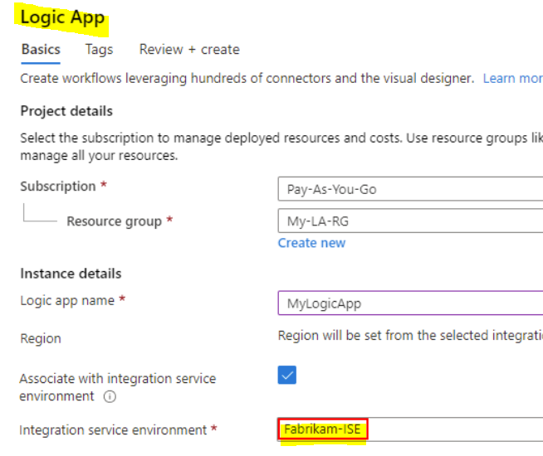

Logic Apps Steps

Create an integration account in the Azure portal
Link the Logic App to the integration account
Add partners, schemas, certificates, maps, and agreements
Create a custom connector for the Logic App

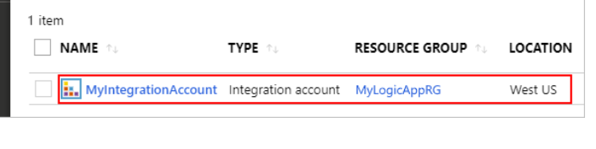
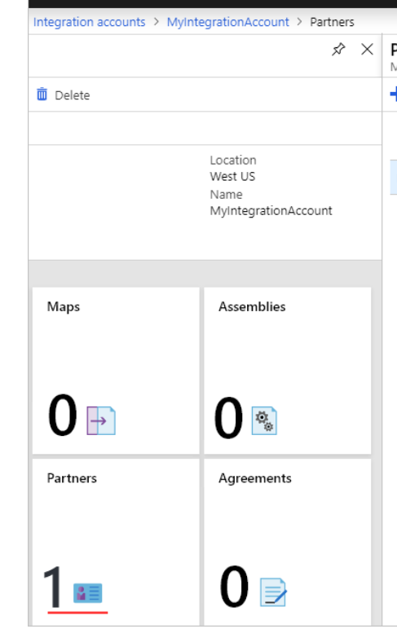

For your Logic App (Consumption) workflow to access the B2B artifacts in your integration account, you must first link your logic app resource to your integration account. Both logic app and integration account must use the same Azure subscription and Azure region.

on-premises data gateway

The on-premises data gateway acts as a bridge to provide quick and secure data transfer between on-premises data (data that isn't in the cloud) and several Microsoft cloud services. These cloud services include Power BI, PowerApps, Power Automate, Azure Analysis Services, and Azure Logic Apps.

A Point-to-Site (P2S) VPN gateway

A Point-to-Site (P2S) VPN gateway connection lets you create a secure connection to your virtual network from an individual client computer. A P2S connection is established by starting it from the client computer. This solution is useful for telecommuters who want to connect to Azure VNets from a remote location, such as from home or a conference. P2S VPN is also a useful solution to use instead of S2S VPN when you have only a few clients that need to connect to a VNet.

A Site-to-Site VPN gateway connection

A Site-to-Site VPN gateway connection is used to connect your on-premises network to an Azure virtual network over an IPsec/IKE (IKEv1 or IKEv2) VPN tunnel. This type of connection requires a VPN device located on-premises that has an externally facing public IP address assigned to it.

Remote access to on-premises applications through Azure AD Application Proxy

Azure Active Directory's Application Proxy provides secure remote access to on-premises web applications. After a single sign-on to Azure AD, users can access both cloud and on-premises applications through an external URL or an internal application portal. For example, Application Proxy can provide remote access and single sign-on to Remote Desktop, SharePoint, Teams, Tableau, Qlik, and line of business (LOB) applications.

Accelerated networking enables single root I/O virtualization (SR-IOV) to a VM, greatly improving its networking performance. This high-performance path bypasses the host from the datapath, reducing latency, jitter, and CPU utilization, for use with the most demanding network workloads on supported VM types. The following picture shows communication between two VMs with and without accelerated networking:

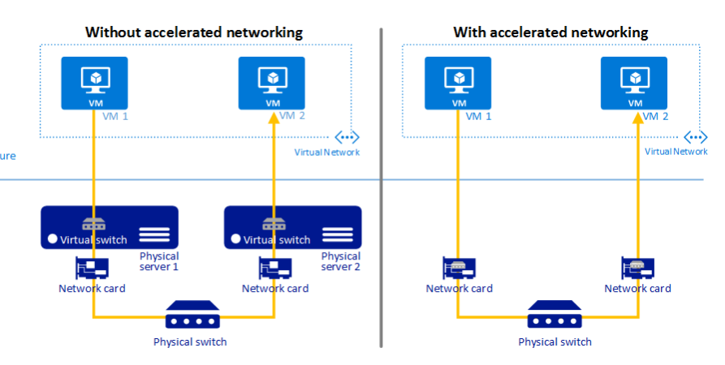
VM Backup - Azure Backup
VM Performance - Accelerated Networking

Use Azure ExpressRoute to create private connections between Azure datacenters and infrastructure on your premises or in a colocation environment. ExpressRoute connections don't go over the public Internet and they offer more reliability, faster speeds and lower latencies than typical Internet connections. In some cases, using ExpressRoute connections to transfer data between on-premises systems and Azure can give you significant cost benefits.
With ExpressRoute, establish connections to Azure at an ExpressRoute location, such as an Exchange provider facility or directly connect to Azure from your existing WAN network, such as a multiprotocol label switching (MPLS) VPN, provided by a network service provider.

Azure Network Watcher provides tools to monitor, diagnose, view metrics, and enable or disable logs for resources in an Azure virtual network. Network Watcher is designed to monitor and repair the network health of IaaS (Infrastructure-as-a-Service) products which includes Virtual Machines, Virtual Networks, Application Gateways, Load balancers, etc. Note: It is not intended for and will not work for PaaS monitoring or Web analytics.

Configure Manifest to include Group Claims in Auth Token

Go to Azure Active Directory to configure the Manifest. Click on Azure Active Directory, and go to App registrations to find your application:

Click on your application (or search for it if you have a lot of apps) and edit the Manifest by clicking on it:

Locate the “groupMembershipClaims” setting. Set its value to either “SecurityGroup” or “All”. To help you decide which:

“SecurityGroup” - groups claim will contain the identifiers of all security groups of which the user is a member.

“All” - groups claim will contain the identifiers of all security groups and all distribution lists of which the user is a member

Azure Search
1. - Create a SearchIndexClient object to connect to the search index
2. - Create an IndexBatch that contains the documents which must be added.
3. - Call the Documents.Index method of the SearchIndexClient and pass the IndexBatch.

Start-AzureStorageBlobCopy : To copy blobs from one container to another

Provision an Azure Service Bus. Configure a topic to receive the device data by using a correlation filter.

Set-AzureRmRoleDefinition Input-File C:\SupportRole.json

The Set-AzureRmRoleDefinition cmdlet updates an existing custom role in Azure Role-Based Access Control. Provide the updated role definition as an input to the command as a JSON file or a PSRoleDefinition object.

"*/read*."* Microsoft.Support/*"
An event is a lightweight notification of a condition or a state change. Event hubs is usually used reacting to status changes

You can form a partition key by concatenating multiple property values into a single artificial partitionKey property. These keys are referred to as synthetic keys. Another possible strategy to distribute the workload more evenly is to append a random number at the end of the partition key value. When you distribute items in this way, you can perform parallel write operations across partitions.

You can resolve issue by recreating the search index with the same settings for all fields except ItemDescription.Select SEARCHABLE option for this field

You can resolve the issue by running the indexer

Which two Dependency Telemetry properties should you store in the database
Telemetry.Context.Operation.Id
Telemetry.Id

Azure AD users must be able to login to the website.
Personalization of the website must be based on membership in Active Directory groups. You need to configure the application’s manifest to meet the authentication requirements

groupMembershipClaims : “All” (valid values are "All" "SecurityGroup" "DistributionList" "DirectoryRole")
oauth2Permissions : true

oauth2Permissions specifies the collection of OAuth 2.0 permission scopes that the web API (resource) app exposes to client apps. These permission scopes may be granted to client apps during consent

You need to configure Kubernetes Custom Resource Definitions (CRD) for the Azure Function

Setting : CRD Type

Azure Function Code : Deployment
Polling Interval : ScaledObject
Azure Storage connection string : Secret

The solution must allow dynamic creation and management of all Azure resources within the AKS cluster. You need to configure an AKS cluster for use with the Azure APIs
Enable the Azure Policy Add-on for Kubernetes to connect the Azure Policy service to the GateKeeper admission controller for the AKS cluster. Apply a built-in policy to the cluster. Does the solution meet the goal?

Ans : No

Instead create an AKS cluster that supports network policy. Create and apply a network to allow traffic only from within a defined namespace

You plan to use the Azure Web App continuous deployment feature.
You need to run the static generation script before the website starts serving traffic. What are two possible ways to achieve this goal? Each correct answer presents a complete solution.

- Create a file named .deployment in the root of the repository that calls a script which generates the static content and deploys the website.
- Add the path to the static content generation tool to WEBSITE_RUN_FROM_PACKAGE setting in the host.json file.
Run your Azure Functions from a package file

In Azure, you can run your functions directly from a deployment package file in your function app. The other option is to deploy your files in the d:\home\site\wwwroot directory of your function app.

To enable your function app to run from a package, you just add a WEBSITE_RUN_FROM_PACKAGE setting to your function app settings.

<URL> | Location of a specific package file you want to run. When you specify a URL, you must also sync triggers after you publish an updated package.

The App Service Environment (ASE) is a powerful feature offering of the Azure App Service that gives network isolation and improved scale capabilities. It is essentially a deployment of the Azure App Service into a subnet of a customer’s Azure Virtual Network (VNet).

VM - 4
Pricing Tier - Isolated

subscriptionClient.RegisterMessageHandler(ProcessMessagesAsync, messageHandlerOptions);

Azure Search

Search the index by regular expression : QueryType
Organize results by counts for name-value pairs : Facets
List Hotels within a specified distance to an airport and that fall within a specified price range : Filter

The SearchParameters.QueryType Property gets or sets a value that specifies the syntax of the search query.
The facets property gets or sets the list of facet expressions to apply to the search query.
The Filter property gets or sets the OData $filter expression to apply to the search query.

To setup offline access, when connecting to your mobile service, use the method GetSyncTable instead of GetTable (example):
var todoTable = client.GetSyncTable<TodoItem>()

Your app should now use IMobileServiceSyncTable (instead of IMobileServiceTable) for CRUD operations. This will save changes to the local database and also keep a log of the changes.
await todoTable.PullAsync("allTodoItems",todo.Table.CreateQuery());

The number of partitions is specified at creation and must be between 2 and 32. There are 6 highways.

You need to implement measures that allow only members of the managers group to see sensitive information. Which two actions should you perform

Exclude the managers group
New-AzureRmSqlDatabaseDataMaskingRule

Dynamic data masking helps prevent unauthorized access to sensitive data by enabling customers to designate how much of the sensitive data to reveal with minimal impact on the application layer. SQL users excluded from masking - A set of SQL users or AAD identities that get unmasked data in the SQL query results

You need to create compute nodes for the solution on Azure Batch. What should you do?
In a .NET method, call the method: BatchClient.PoolOperations.CreatePool
A Batch job is a logical grouping of one or more tasks. A job includes settings common to the tasks, such as priority and the pool to run tasks on. The app uses the BatchClient.JobOperations.CreateJob method to create a job on your pool.

Box 1: Recurrence Box 2: Insert Entity Box 3 (if true): Tier Blob Box 4: (if false): Leave blank.
https://docs.microsoft.com/en-us/azure/logic-apps/logic-apps-perform-data-operations

API – Permission - Type
Azure Storage - user_impersonation - delegated
Microsoft Graph - User.Read - delegated

Run background tasks with WebJobs in Azure App Service

WebJob types
The following table describes the differences between continuous and triggered WebJobs.
WEBJOB TYPES
Continuous | Triggered
Starts immediately when the WebJob is created. To keep the job from ending, the program or script typically does its work inside an endless loop. If the job does end, you can restart it. Typically used with WebJobs SDK. | Starts only when triggered manually or on a schedule.
Runs on all instances that the web app runs on. You can optionally restrict the WebJob to a single instance. | Runs on a single instance that Azure selects for load balancing.
Supports remote debugging. | Doesn't support remote debugging.
Code is deployed under \site\wwwroot\app_data\Jobs\Continuous. | Code is deployed under \site\wwwroot\app_data\Jobs\Triggered.

Which three items must you identify when configuring dynamic data masking?
Table,Column,Schema

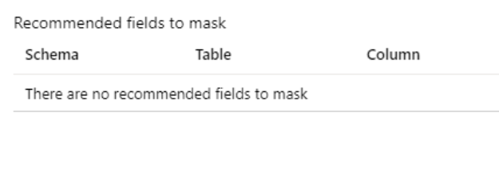

new CosmosClient(EndpointUri, PrimaryKey)

You implement Azure Service Bus to publish alarms. Each alarm controller uses Azure Service Bus to receive alarm signals as part of a transaction. Alarm events must be recorded for audit purposes. Each transaction record must include information about the alarm type that was activated. You need to implement a reply trail auditing solution

Assign the value of the hazard message SessionID property to the SequenceNumber property
Assign the value of the hazard message SequenceNumber property to the DeliveryCount propert
You need to migrate on-premises shipping data to Azure. What should you use?
Azure Database Migration service

Migrate from on-premises or cloud implementations of MongoDB to Azure Cosmos DB with minimal downtime by using Azure Database Migration Service. Perform resilient migrations of MongoDB data at scale and with high reliability. Scenario: Data migration from on-premises to Azure must minimize costs and downtime.

You use Azure Table storage to store customer information for an application. The data contains customer details and is partitioned by last name. You need to create a query that returns all customers with the last name Smith.

TableQuery.GenerateFilterCondition("PartitionKey", QueryComparisons.Equal, "Smith")

You must ensure that the external party cannot access the data in the SSN column of the Person table. Will each protection method meet the requirement? To answer, drag the appropriate responses to the correct protection methods. Each response may be used once, more than once, or not at all.

Enable AlwaysOn encryption - Yes
Set the column encryption setting to disabled - No
Assign users to the public fixed database role - Yes
Store column encryption keys in system catalog view in the database – No

In SQL Database, the VIEW permissions are not granted by default to the public fixed database role. This enables certain existing, legacy tools (using older versions of DacFx) to work properly. Consequently, to work with encrypted columns (even if not decrypting them) a database administrator must explicitly grant the two VIEW permissions

All cryptographic keys are stored in an Azure Key Vault.

Configure the web app to the Standard App Service Tier
Enable autoscaling on the web app
Add a scale rule
Add a Scale condition

You need to develop code that can insert multiple sets of user information.

TableBatchOperation op = new TableBatchOperation();
table.ExecuteBatch(op);

: Only storage accounts of kind StorageV2 (general purpose v2) and BlobStorage support event integration. Storage (general purpose v1) does not support integration with Event Grid

getContext().getRequest()
if(isNaN(i)["tip"]
r.setBody(i)

Not necessary to convert the account, instead move photo processing to an Azure Function triggered from the blob upload..

These profiles support the following compression encodings: Gzip (GNU zip), Brotli

In the Azure Application Gateway’s HTTP setting, enable the Use for App service setting
In the Azure Application Gateway’s HTTP setting, set the value of the Override backend path option to contoso22.azurewebsites.net

In case of end to end SSL, trusted Azure services such as Azure App service web apps do not require whitelisting the backends in the application gateway. Therefore, there is no need to add any authentication certificates

You provide an Azure API Management managed web service lo clients. The back end web service implements HTTP Strict Transport Security (HSTS). Every request to the backend service must include a valid HTTP authorization header. You need to configure the Azure API Management instance with an authentication policy. Which two policies can you uses?

Certificate Authentication
OAuth Client Credential Grant

You can order by multiple properties. A query that orders by multiple properties requires a composite index

Policy for cosmos DB

The function editor built into the Azure portal lets you update the function.json file and the code file for a function. The host.json file, which contains some runtimespecific configurations, is in the root folder of the function app.

You are writing code to create and run an Azure Batch job. You have created a pool of compute nodes. You need to choose the right class and its method to submit a batch job to the Batch service. Which method should you use?
CloudJob.CommitAsync(IEnumerable<BatchClientBehavior>, CancellationToken)

To create an internal load balancer, create a service manifest named internal-lb.yaml with the service type LoadBalancer and the azure-load-balancer-internal annotation

apiVersion: v1 kind: Service
service.beta.kubernetes.io/azure-load-balancer-internal: "true"
type: LoadBalancer

az group create
az aks create
kubectl apply
az aks get-credentials

* 1 Create a SearchlndexClient object to connect to the search index
* 2. Create an IndexBatch that contains the documents which must be added.
* 3. Call the Documents.Index method of the SearchIndexClient and pass the IndexBatch..

new CosmosClient(EndpointUri, PrimaryKey)

The application uses Azure Search for allowing users to search for keywords in the project data. You need to implement code that creates the object which is used to create indexes in the Azure Search service.

SearchlndexCIient
SearchServiceClient

- Encrypt the on-premises VHD by using BitLocker without a TPM. Upload the VM to Azure Storage
- Run the Azure PowerShell command SetAzureRMVMOSDisk To use an existing disk instead of creating a new disk you can use the Set-AzureRMVMOSDisk command
- Run the Azure PowerShell command SetAzureRmVMDiskEncryptionExtension Use the Set-AzVMDiskEncryptionExtension cmdlet to enable encryption on a running IaaS virtual machine in Azure.

Instead create an AKS cluster that supports network policy. Create and apply a network to allow traffic only from within a defined namespace.

You write a new event subscription at the scope of your resource. The event must be invalidated after 3 specific period of time. You need to configure Event Grid to ensure security.

Custom topics use either Shared Access Signature (SAS) or key authentication. Microsoft recommends SAS, but key authentication provides simple programming, and is compatible with many existing webhook publishers.

Event Grid supports two ways of validating the subscription: ValidationCode handshake (programmatic) and ValidationURL handshake (manual).

Which pages visited by users most often correlate to a product purchase - Users
How does load time of the product display page affect a user decision to purchase a product - Impact
Which events most influence a users decision to continue to use the application - Retention
Are there places in the application that users often perform repetitive actions - User flows

Creating an image directly from the VM ensures that the image includes all of the disks associated with the VM, including the OS disk and any data disks. Before you begin, make sure that you have the latest version of the Azure PowerShell module. You use Sysprep to generalize the virtual machine, then use Azure PowerShell to create the image.

Azure Blob Storage – for storing an image.

BatchClient.PoolOperations.CreateJob

You need to grant the role

New-AzureRmRoleAssignment
az role assignment create

You need to implement measures that allow only members of the managers group to see sensitive information. Which two actions should you perform?

Exclude the manager group
Run the following cmd - New-AzureSqlDatabaseDataMaskingRule

Users must be able to search for restaurants by name, description, location, and cuisine.
Users must be able to narrow the results further by location, cuisine, rating, and family-friendliness

Location,Description : [IsSearchable.IsFilterable.IsSortable,IsFacetable]
Rating , Cuisuines : [IsSearchable.IsFilterable,IsFacetable]
Family Fridendly : [Isfilteratable,IsFacetable]

You develop an Azure web app. You monitor performance of the web app by using Application Insights. You need to ensure the cost for Application Insights does not exceed a preset budget.

Implement adaptive sampling using the Application Insights SDK.

Adaptive sampling is the default for the ASP.NET SDK. Adaptive sampling automatically adjusts to the volume of telemetry that your app sends. It operates automatically in the SDK in your web app so that telemetry traffic on the network is reduced.
Get-AzSubscription
Set-AzContext -SubscriptionId
Get-AzStorageAccountKey
$secretvalue = ConvertTo-SecureString -AsPlainText -Force
Get-AzKeyVaultSecret

You plan to deploy a web app to App Service on Linux. You create an App Service plan. You create and push a custom Docker image that image that contains the web app to Azure Container Registry. You need to access the console logs generated from inside the container in real-time.

az webapp log config --name ContosoWeb --resource-group ContosoDevRG --docker-container-logging filesystem
az webapp log download --name ContosoWeb --resource-group ContosoDevRG

App Service passes user claims to your application by using special headers. External requests aren't allowed to set these headers, so they are present only if set by App Service. Some example headers include: X-MS-CLIENT-PRINCIPAL-NAME

You need to capture the data required to implement the Usage Analytics feature of Application Insights. Which three data values should you capture?

Trace , User Id , Events

You are developing an internal website for employees to view sensitive data. The website uses Azure Active Directory (AAD) for authentication. You need to implement multifactor authentication for the website. What should you do?

In Azure AD, create a new conditional access policy
Upgrade to Azure AD Premium

Update the web.config file to include the applicationInitialization configuration element. Specify custom initialization actions to run the scripts. – No

Some apps might require custom warm-up actions before the swap. The applicationInitialization configuration element in web.config lets you specify custom initialization actions. The swap operation waits for this custom warm-up to finish before swapping with the target slot.

You develop and deploy an Azure App Service API app to a Windows-hosted deployment slot named Development. You create additional deployment slots named Testing and Production. You enable auto swap on the Production deployment slot.
You need to ensure that scripts run and resources are available before a swap operation occurs.
Solution: Enable auto swap for the Testing slot. Deploy the app to the Testing slot.

Settings that are swapped:
- General settings, such as framework version, 32/64-bit, web sockets
- App settings (can be configured to stick to a slot)
- Connection strings (can be configured to stick to a slot)
- Handler mappings
- Public certificates
- WebJobs content
- Hybrid connections *
- Service endpoints *
- Azure Content Delivery Network *
- Path mappings
Settings that aren't swapped:
- Publishing endpoints
- Custom domain names
- Non-public certificates and TLS/SSL settings
- Scale settings
- WebJobs schedulers
- IP restrictions
- Always On
- Diagnostic settings
- Cross-origin resource sharing (CORS)
- Virtual network integration
- Managed identities
- Settings that end with the suffix _EXTENSION_VERSION

https://docs.microsoft.com/en-us/azure/app-service/deploy-staging-slots

Some apps might require custom warm-up actions before the swap. The applicationInitialization configuration element in web.config lets you specify custom initialization actions. The swap operation waits for this custom warm-up to finish before swapping with the target slot. Here's a sample web.config fragment.

<system.webServer>
<applicationInitialization>
<add initializationPage="/" hostName="[app hostname]" />
<add initializationPage="/Home/About" hostName="[app hostname]" />
</applicationInitialization>
</system.webServer>

You can also customize the warm-up behavior with one or both of the following app settings:

WEBSITE_SWAP_WARMUP_PING_PATH : The path to ping to warm up your site
WEBSITE_SWAP_WARMUP_PING_STATUSES: Valid HTTP response codes for the warm-up operation
WEBSITE_WARMUP_PATH : A relative path on the site that should be pinged whenever the site restarts

A request that's routed to the "staging" slot has the cookie x-ms-routing-name=staging. A request that's routed to the production slot has the cookie x-ms-routing-name=self.

New-AzWebAppSlot -ResourceGroupName [resource group name] -Name [app name] -Slot [deployment slot name] -AppServicePlan [app service plan name]

$ParametersObject = @{targetSlot = "[slot name – e.g. "production"]"}
Invoke-AzResourceAction -ResourceGroupName [resource group name] -ResourceType Microsoft.Web/sites/slots -ResourceName [app name]/[slot name] -Action applySlotConfig -Parameters $ParametersObject -ApiVersion 2015-07-01
You need to validate the client certificate in the web app. To answer, select the appropriate options in the answer area

Client Certification location HTTP request header
Encoding type Base64

the certificate will be available through the HttpRequest.ClientCertificate property

Create the Azure Functions app with a Consumption plan type.
Create a system-assigned managed identity for the application.
Create an access policy in Key Vault for the application identity.

Deploy the website to an App Service that uses the Standard service tier. Configure the App Service plan to automatically scale when the CPU load is high.’

getContext().getRequest();
if(isNan(i)[“tip”] || i[“tip”] === null)
r.setBody(i);

Use the Durable Function async pattern to process the blob data. (timeout issue)
NO

Pass the HTTP trigger payload into an Azure Service Bus queue to be processed by a queue trigger function and return an immediate HTTP success response.
YES

Configure the app to use an App Service hosting plan and enable the Always On setting (timeout issue)
NO

The application must read the transaction logs of all the changes that occur to the blobs and the blob metadata in the storage account for auditing purposes. The changes must be in the order in which they occurred, include only create, update, delete, and copy operations and be retained for compliance reasons.
You need to process the transaction logs asynchronously.

Enable the change feed on the storage account and process all changes for available events.

Docker File
FROM mcr.microsoft.com/dotnet/aspnet:3.1
WORKDIR /app
COPY --from=build-env /app/out .
ENTRYPOINT ["dotnet", "aspnetapp.dll"]

Use a Consumption plan. Configure the Function App to use an Azure Blob Storage trigger.

“name” : “[concat(copyIndex(),’storage’,uniqueString()]”
“copy” : {“name”:”storagesetup”,”count”:3}
“dependsOn” : “[variables(‘loadBalancerName’)]” , “[varialbes(‘virtualNetworkName’)]”

maxDequeueCount - The number of times to try processing a message before moving it to the poison queue. Default value is 5.

When a VM is provisioned the firewall must be automatically configured before it can access Azure resources.
Supporting services must be installed by using an Azure PowerShell script that is stored in Azure Storage.

Firewall configuration : Run command
Supporting services script : Hybrid Runbook Worker

You can use the Hybrid Runbook Worker feature of Azure Automation to run runbooks directly on the machine that's hosting the role and against resources in the environment to manage those local resources. Runbooks are stored and managed in Azure Automation and then delivered to one or more assigned machines.

Update-AzVM -ResourceGroupName “ContosoRG” -VM $vm -IdentityId: $SystemAssigned

Enable developers to write the functions by using the Rust language : Custom handler
Declaratively connect to an Azure Blob Storage account : Trigger

You need to configure the application settings so that diagnostic data is stored as required.

WEBSITES_ENABLE_APP_SERVICE_STORAGE true
DIAGDATA /home

If WEBSITES_ENABLE_APP_SERVICE_STORAGE setting is unspecified or set to true, the /home/ directory will be shared across scale instances, and files written will persist across restarts.

All traffic must be secured with SSL. The Azure Application Gateway instance is used by multiple web apps.

In the Azure Application Gatewayג€™s HTTP setting, enable the Use for App service setting.
In the Azure Application Gatewayג€™s HTTP setting, set the value of the Override backend path option to contoso22.azurewebsites.net.

Use the Azure Blob Storage change feed to trigger photo processing. NO

var id = await src.AcquierLeaseAsync(null);
If null, an infinite lease will be acquired. If not null, this must be 15 to 60 seconds.

The Lease Container operation establishes and manages a lock on a container for delete operations. The lock duration can be 15 to 60 seconds, or can be infinite.

The BreakLeaseAsync method initiates an asynchronous operation that breaks the current lease on this container.

The archive access tier has the lowest storage cost. But it has higher data retrieval costs compared to the hot and cool tiers. Data in the archive tier can take several hours to retrieve depending on the priority of the rehydration. For small objects, a high priority rehydrate may retrieve the object from archive in under 1 hour.

SLA : 1 and 15 hrs

az appservice plan create –name websitePlan –sku B1 –hyper-v
az webapp create –plan websitePlan –deployment-source-url images.azurecr.io/website:v1.0.0
az webapp config container set -docker-registry-server-url https://images.azurecr.io -u admin -p admin

You need to update the metadata of the blobs.

Metadata.Add
SetMetadataAsync
SetPropertiesAsync

metadata.Add("docType", "textDocuments");
blob.SetMetadataAsync(metadata);
blob.SetPropertiesAsync();

You are developing an Azure solution to collect point-of-sale (POS) device data from 2,000 stores located throughout the world. A single device can produce
2 megabytes (MB) of data every 24 hours. Each store location has one to five devices that send data.
You must store the device data in Azure Blob storage. Device data must be correlated based on a device identifier.
You need to implement a solution to receive the device data. : Yes

CloudQueueClient

Object storage data tiering between hot, cool, and archive is supported in Blob Storage and General Purpose v2 (GPv2) accounts. General Purpose v1 (GPv1) accounts don't support tiering.

Upgrade the storage account to GPv2
Copy the data to be archived to a standard GPV2 storage account
Chage the storage account access tier from hot to cool

url=http://169.254.169.254/metadata/identity/oauth2/token
return JsonConver.DeserializObject<Dictionlay<string,string>>(paylod);

“compositeIndexes” : [
“Path”: “/city” , “order”:”descending”
]

Deploy Solution : Helm
View cluster and external IP addressing : KubeCtl
Implement a single , public IP endpoint that is routed to multiple microservices : Ingress Controller

To create the ingress controller, use Helm to install nginx-ingre
An ingress controller is a piece of software that provides reverse proxy, configurable traffic routing, and TLS termination for Kubernetes services.

FutureOrders : SQLFilter
HighPriorityOrders : CorrelationFilter
InternationalOrders : SQLFilter
HighQuantityOrders : SQLFilter
AllOrders : No Filter

You need to select a partition key.
a concatenation of multiple property values with a random suffix appended
a hash suffix appended to a property value

Store the data from which the change feed is generated : Monitored container
Coordinate processing of the change feed across multiple workers : Lease container
Use the change feed processor to listen for changes : Host
Handle each batch of changes : Delegate

The monitored container: The monitored container has the data from which the change feed is generated.
The lease container: The lease container acts as a state storage and coordinates processing the change feed across multiple workers.
The host: A host is an application instance that uses the change feed processor to listen for changes
The delegate: The delegate is the code that defines what you, the developer, want to do with each batch of changes that the change feed processor reads.

In App registrations , select New registration
Select the Azure AD instance
Create a new application and provide the name , account type and redirect URI

You need to implement multifactor authentication for the website.
In Azure AD , create a new conditional access policy
Upgrade to Azure AD Premium

Azure Cosmos DB now provides a new RBAC role, Cosmos DB Operator. This new role lets you provision Azure Cosmos accounts, databases, and containers, but can’t access the keys that are required to access the data

Configure the Azure Web App for the website to allow only authenticated requests and require Azure AD log on.
No : Instead in the Azure AD application’s manifest, set value of the groupMembershipClaims option to All.

No : To configure Manifest to include Group Claims in Auth Token

Enable retention period and accidental deletion : Soft delete
Enforce retention period and accidental deletion : Purge protection

The back end web service implements HTTP strict transport security (HSTS) . Every request to the backend service must include a valid HTTP authorization header

Certificate Authentication
OAuth Client Credential Grant

You need to configure the websiteג€™s Azure AD Application so that userג€™s permissions can be used with the Azure Blob containers.

Azure Storage : user_impersonation delegated
Microsoft Graph: User.Read delegated

app.UseAuthenticaion
app.UserAuthorization
app.UseStaticFiles

If the stored intake forms are downloaded from storage by a third party, the contents of the forms must not be compromised.

Instead use an Azure Key vault and public key encryption. Store the encrypted from in Azure Storage Blob storage.
No Cosmos DB

az keyvault create
az keyvault key create
az vm create
az vm encryption create –volume-type all

Get-AzSubscription
Set-AzContext -SubscriptionId
Get-AzStorageAccoutKey
Set-AzKeyVaultSecret
Get-AzKeyValutSecret

You must grant a virtual machine (VM) access to specific resource groups in Azure Resource Manager.
You need to obtain an Azure Resource Manager access token.

Use an X.509 certificate : NO
Instead run the Invoke-RestMethod cmdlet to make a request to the local managed identity for Azure resources endpoint

iOS DeliveryRulesDeviceConditionParameters
HTTP_USER_AGENT DeleiverRuleRequestHeaderConditionParameters iOS

Instead in the Azure AD application’s manifest, set value of the groupMembershipClaims option to All. In the website, use the value of the groups claim from the
JWT for the user to determine permissions.

A recent security audit found that several web services can be called without any authentication.
Which API management policy should you implement?

Validate-jwt

Set-variable Inbound
Cache-lookup-value Inbound
Cache-store-value Outbound
Find-and-replace Outbound

<outbound>
<base />
<cache-store duration="3600" />
</outbound>

Access key vault secret
String var1 = Environment.GetEnvironmentVariable(“KEY_VAULT_URI”);
Var var2 = new SecretClient (new Uri(var1),new DefaultAzureCredential) ());

You need to configure the API to make the updates.
Microsoft Graph API , Azure API Management

You implement a user delegation SAS token to communicate with Azure Blob storage.
You need to revoke the token.
What are two possible ways to achieve this goal?

Revoke the delegation key , Delete the stored access policy
revoke-delegation-keys command

You need to securely transfer the key to Azure Key Vault.

Generate a Key Exchange Key (KEK)
Retrieve the Key Exchange Key (KEK) public key
Generate a key transfer blog file by using the HSM vendor-provided tool
Run the az keyvault key import command
The Azure Logic app must securely access the Azure Blob storage account. Azure AD resources must remain if the Azure Logic app is deleted.
You need to secure the Azure Logic app.

Create a user-assigned managed identity and assign role-based access controls.

Create an Azure Function to use a trigger for Azure Cosmos DB. Configure the trigger to connect to the container.

Cosmos DB

SELECT * FROM c WHERE c.EmployeeId > '12345'
SELECT * FROM c WHERE c.UserID = '12345'

Container is 400 R/Us – No
First query In-partition query – No
Second query Cross-partition query – Yes

Var app = ConfidentialClientApplicationBuilder.Create(config.ClientId)
await app.AcquireTokenForClient(scopes).ExecuteAsync();

Telemetry.Id
Telemetry.Context.Operation.Id

Edge nodes must be purged of all cache assets
The compression type is supported

Share session state across all ASP.NET web applications.
Support controlled, concurrent access to the same session state data for multiple readers and a single writer.
Save full HTTP responses for concurrent requests.

Enable Application Request Routing (ARR) : No
Instead deploy and configure Azure Cache for Redis

IDatabase cache = Connection.GetDatabase();
cache.StringSet(“Team”,””)

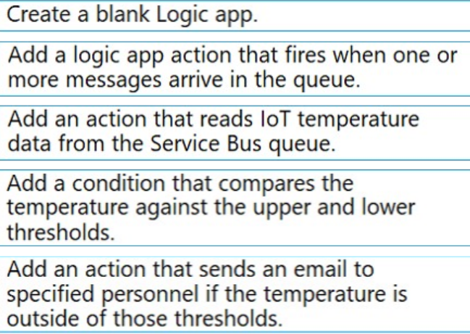

Which pages visited by users most often correlate to a product purchase : Users
How does load time of the product display page affect a users decision to purchase a product : Impact
Which events most influence a users decision to continue to use the application : Retention
Are there places in the application that users often perform repetitive actions : User Flows

You need to ensure that you can access the news API by using an Azure API Management service instance.
New-AzureRmApiManagementBackendProxy -Url $ApiUrl

You need to implement a reply trail auditing solution.
Assign the value of the hazard message SessionID property to the ReplyToSessionId property.
Assign the value of the hazard message MessageId property to the CorrelationId property.

The timeout period elapsed prior to obtaining a connection from the pool. This may have occurred because all pooled connections were in use and max pool size was reached
You need to prevent the exception.

Convert the Azure Function to the Premium plan

With the Premium plan the max outbound connections per instance is unbounded compared to the 600 active

let startTimestamp = ago(1d)
distinct ContainerID
where ContainerID in (ContainerIDs)
summarize count() by Compute

az webapp log config –name Contosoweb –resource-group ContosoDevRG –docker-container-logging
az webapp log download –name ContosoWeb –resource-group ContosoDevRG

If the app is not responding, you must send an alert to support staff.
Which two test types can you use?

multi-step web
URL ping

API calls must be cached. Customers must not be able to view cached data for other customers.
<cache-lookup caching-type=”Internal” downstream-caching-type=”Private”>
<vary-by-header>
Authorization
</vary-by-header>

Verify that the websites respond within a specified time threshold. Dependent requests such as images and JavaScript files must load properly.

Create a multi-step web test to query the home page.

You must send an alert when any of the function endpoints are unavailable or responding too slowly.
You need to monitor the availability and responsiveness of the functions.

Create a timer triggered function that calls TrackAvailability() and send the results to Application Insights.
telemetryClient.TrackAvailability(availability)- inside the function

Register the application with the Microsoft identity platform
Build a client by using the client app ID
Create an authentication provider
Create a new instance of the GraphServiceClient
Invoke the request to the Microsoft Graph API

https://docs.microsoft.com/en-us/azure/logic-apps/monitor-logic-apps-log-analytics

The Logic App must use Azure Monitor logs to record and store information about runtime data and events. The logs must be stored in the Azure Blob storage account.
You need to set up Azure Monitor logs and collect diagnostics data for the Azure Logic App.

Create a Log Analytics workspace
Install the Logic Apps Management solution
Add a diagnostic setting to the Azure Logic App

For VM

Create a Log Analytics workspace
Add a VMInsights solution
Install agents on the VM and VM scale set to be monitored
Create an application insights resource

<policies>
<inbound>
<!-- statements to be applied to the request go here -->
</inbound>
<backend>
<!-- statements to be applied before the request is forwarded to
the backend service go here -->
</backend>
<outbound>
<!-- statements to be applied to the response go here -->
</outbound>
<on-error>
<!-- statements to be applied if there is an error condition go here -->
</on-error>
</policies>

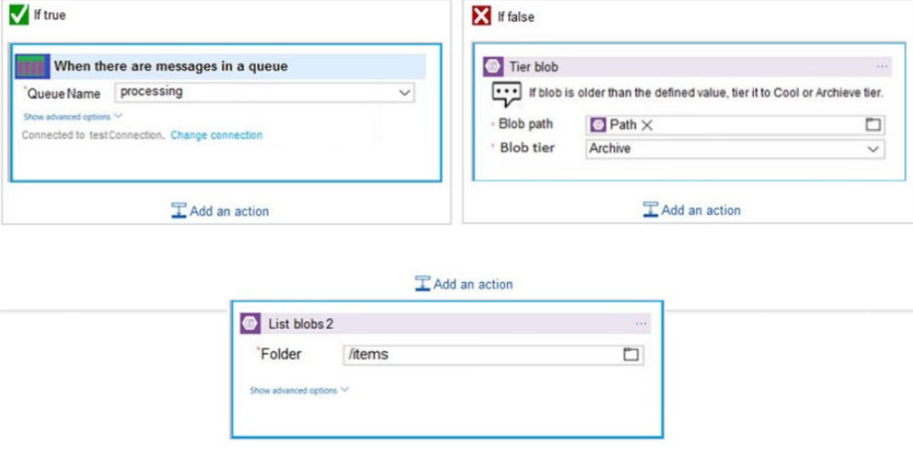

You are developing an Azure solution to collect point-of-sale (POS) device data from 2,000 stores

Azure service Bus

Edit B2B workflows : Enterprise Integration Pack
Edit definitions in JSON : Code View Editor
Visually add functionality : Logic Apps Designer

You need to complete the configuration
az servicebus queue create
--resource-group fridge-rg
--namespace-name fridge-ns
--name fridge-q

Create an Azure Function App that uses an Azure Service Bus Queue trigger.

Create a Single Service Bus Namespace
Create a Service Bus topic for each restaurant for which a driver can receive messages
Create a Service Bus subscription for each restaurant for which a driver can receive orders

await hub.SendWindowsNativeNotificationAsync(windowsToastPayload);

Provide transactional support.
Provide duplicate detection.
Store the messages for an unlimited period of time

Azure Service Bus Topic , Azure Service Bus Queue

API Management

Target : Azure Resource
Gateway credentials : Client cert

You need to configure Event Grid

WebHook event delivery : SAS tokens
Topic publishing : ValidationCode handshake

You need to ensure that the subscription client processes all messages.

subscriptionClient.RegisterMessageHandler(ProcessMessagesAsync,messageHandlerOptions);

Don't use a VM, instead create an Azure Function App that uses an Azure Service Bus Queue trigger.

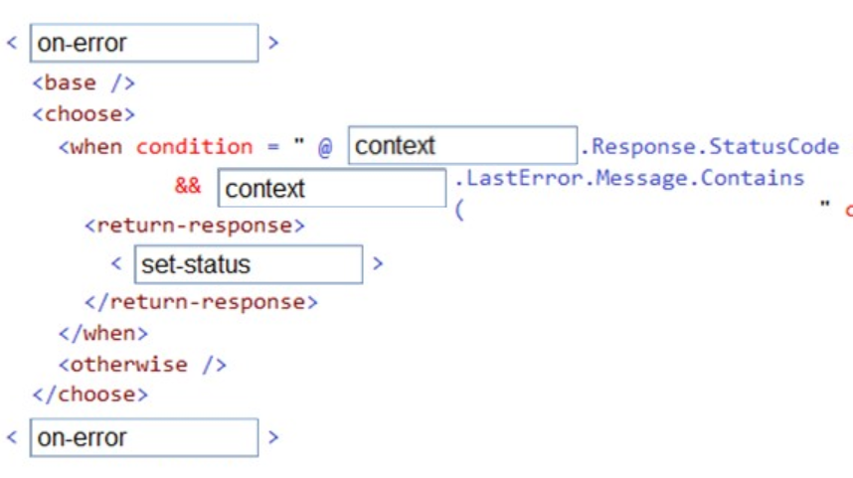

request.Headers.Add("ServiceBusNotification-Format", "windows")
request.Content = new StringContent(content, Encoding.UTF8,
"application/octet-stream");

https://stackoverflow.com/questions/31346714/how-to-send-raw-notification-to-azure-notification-hub/31347901

Event Source : Azure Event Grid
Event Receiver : Azure Logic App
Event Handler : Azure Service Bus

A fellow administrator named Jon Ross used an Azure Resource Manager template to deploy a virtual machine and an Azure Storage account.
You need to identify the Azure Resource Manager template the Jon Ross used.

View template from deployment history not container blade

A fellow administrator named Jon Ross used an Azure Resource Manager template to deploy a virtual machine and an Azure Storage account.
You need to identify the Azure Resource Manager template the Jon Ross used.

You access the Resource Group blade : Yes

You need to move VM1 to Host2.
From the Redeploy blade, click Redeploy.

You need to make sure that the password is not stored in plain text.
You are preparing to create the necessary components to achieve your goal.

An Azure Key Vault
An access policy

You want to secure all traffic to mywebapp1 by using SSL
You open the Azure Application Gateway HTTP setting and set the Override backend path option to mywebapp1.azurewebsites.net.

You don’t need to authentication certificate for mywebapp1.azurewebsites.net.

You use the WebJobs SDK to design a triggered App Service background task that automatically invokes a function in the code every time new data is received in a queue.

You need to ensure that the ARM template allows for as many virtual machines as possible to remain accessible in the event of fabric failure or maintenance.
Which of the following is the value that you should configure for the platformFaultDomainCount property?

The number of fault domains for managed availability sets varies by region - either two or three per region.

Triggered web jobs : runs on a single instance , doesn’t support remote debugging
Continuous web jobs : runs on all instances , have an option to restrict to single instance , supports remote debugging

You need to ensure that an email notification is sent when information is received from IoT devices, and that compute cost is reduced for function app.

Consumption plan
SendGrid binding

[FunctionName("SendEmail")]
public static void Run(
[ServiceBusTrigger("myqueue", Connection = "ServiceBusConnection")] Message email,
[SendGrid(ApiKey = "CustomSendGridKeyAppSettingName")] out SendGridMessage message)

You need to devise a strategy to migrate MongoDB to the Azure Cosmos DB account.
You include the Data Management Gateway tool in your migration strategy.

What else is required : mongorestore

Process transaction logs asynchronously for changes that occur to the blobs and the blob metadata.
Process changes in the order in which they occurred.
Retain changes for compliance reasons.

You use Azure Event Grid with a subscriber Azure Function app.

You want to implement dynamic data masking to hide the data in the email_address field.

ALTER TABLE [dbo].[Weyland].[Customers]
ALTER COLUMN [email_address]
ADD MASKED WITH (FUNCTION = 'email()')

The Set-AzSqlDatabaseDataMaskingPolicy cmdlet sets the masking policy for the database but does not set the masking rule.

You run the Set-AzSqlDatabaseDataMaskingRule
-DatabaseName "Weyland" -SchemaName "dbo"
-TableName "Customers" -ColumnName "email_address"
-MaskingFunction "email" Powershell cmdlet

Data masking to hide the data in the email_address

Multi factor authentication - In Azure AD, create a conditional access policy.

You configure the use of Azure AD Identity Protection - Yes
You configure the use of Azure AD Privileged Identity Management - No

You also need to make sure the developers use their on-premises Active Directory account for authentication. Your strategy should allow for authentication prompts to be kept to a minimum : Active Directory integrated authentication.

Run the az keyvault update --enable-soft-delete true --enable-purge-protection true CLI.

az monitor metrics alert create -n myAlert -g myResourceGroup –scopes targetResourceID –conditoni avg Percentage CPU > 85 –windows size 5m

You need to ensure that the application is highly available and that the users streaming experience is constant. You include the use of an Azure Content Delivery Network (CDN) in your design.

Configure the web app to the Standard App Service Tier. The Standard tier supports auto-scaling, and we should minimize the cost.

The Azure Log Analytics workspace is set up to gather performance counters associated with security from these linked servers.
You have to make sure that alert rules allow for dimensions, and that alert creation time should be kept to a minimum. Furthermore, a single alert notification must be created when the alert is created and when the alert is resolved.
You need to make use of the necessary signal type when creating the alert rules.

The Metric signal type.

You want the application to allow customers to search the index by using regular expressions.

Configure the QueryType property of the SearchParameters class.
The SearchParameters.QueryType Property gets or sets a value that specifies the syntax of the search query. The default is 'simple'. Use 'full' if your query uses the Lucene query syntax.
Lucene Query Parser syntax for specialized query forms: wildcard, fuzzy search, proximity search, regular expressions

You need to update the definitions for an existing Logic App.
the Logic App Code View

API Management allows to secure access to the back-end service of an API using client certificates.

You want the application to list holiday accommodation venues that fall within a specific price range and are within a specified distance to an airport.
Configure the Filter property of the SearchParameters class.

For business-to-business (B2B) solutions and seamless communication between organizations, you can build automated, scalable, enterprise integration workflows by using Azure Logic Apps with the Enterprise Integration Pack (EIP).

You create the index in Azure Search. You now need to use the Azure Search .NET SDK to import the relevant data into the Azure Search service.

Create a SearchIndexClient object to connect to the search index
Create an IndexBatch that contains the documents which must be added
Call the Documents.Index method of the SearchIndexClient and pass the IndexBatch.

Add a subject prefix to sign-out events. Create an Azure Event Grid subscription. Configure the subscription to use the subjectBeginsWith filter.

You need to configure Azure CDN for the Shipping web site.
Use Azure Content Delivery Network (CDN) and ensure maximum performance for dynamic content while minimizing latency and costs.

Tier : Standard , Profile : Akamai , Optimization : dynamic site acceleration

DSA includes various techniques that benefit the latency and performance of dynamic content. Techniques include route and network optimization, TCP optimization, and more.

VM Backup : Azure Backup
Performance : Accelerated Networking

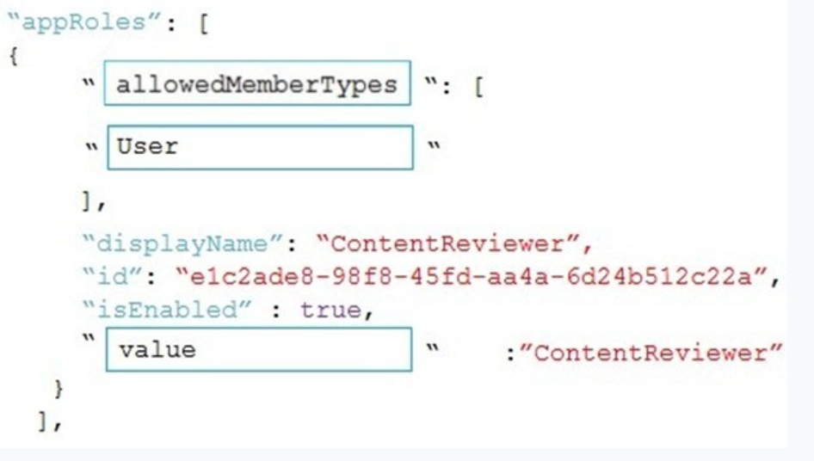

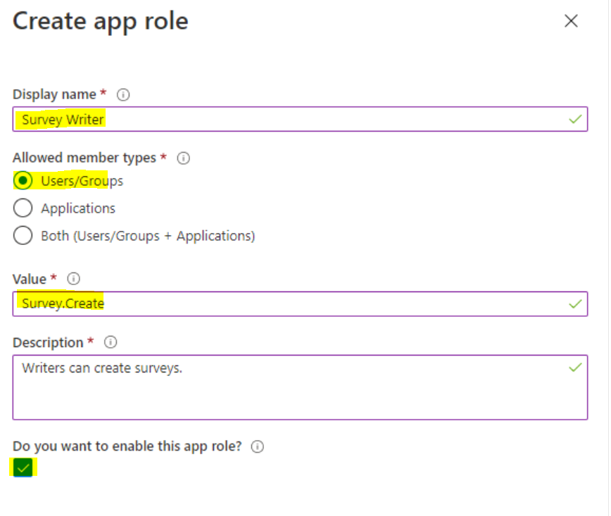
Specifies the value of the roles claim that the application should expect in the token. The value should exactly match the string referenced in the application's code.

allowedMemberTypes specifies whether this app role definition can be assigned to users and groups by setting to "User"
You need to add code at line AM09 to ensure that users can review content using ContentAnalysisService.

AD App Manifest

"oauth2Permissions": [
{
"adminConsentDescription": "Allow the app to access resources on behalf of the signed-in user.",
"adminConsentDisplayName": "Access resource1",
"id": "<guid>",
"isEnabled": true,
"type": "User",
"userConsentDescription": "Allow the app to access resource1 on your behalf.",
"userConsentDisplayName": "Access resources",
"value": "user_impersonation"
}
],

Specifies whether this web app can request OAuth2.0 implicit flow access tokens. The default is false. This flag is used for browser-based apps, like JavaScript single-page apps

“oauth2Permissions”:[“login”]
“oauth2AllowImplicitFlow”:true

You need to ensure that network security policies are met.
How should you configure network security?

SSL certificate : Valid root certificate
Proxy type : Azure Application Gateway

This type of routing is known as application layer (OSI layer 7) load balancing. Azure Application Gateway can do URL-based routing and more

You need to add YAML markup at line CS17 to ensure that the ContentUploadService can access Azure Storage access keys.

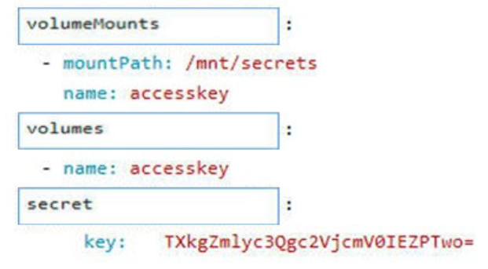

volumeMounts (mountPath , name) , volumes (name) , secret (key)

you need to add code at line AM10 of the application manifest to ensure that the requirement for manually reviewing content can be met.

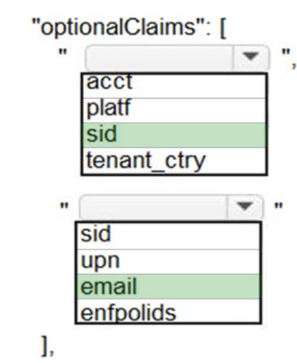
optionalClaims : [“sid”;”email”]

email : The addressable email for this user, if the user has one.
sid : Session ID, used for per-session user sign-out.

The majority of these claims can be included in JWTs for v1.0 and v2.0 tokens

You need to secure the Shipping Function app.

Authorization level : Function
User claims : JSON Web Token
Trigger type : HTTP

secure the Shipping Logic App : Integration Service Environment (ISE)

Variable type to access Azure Key Vault secret values : Querystring

You need to correct the corporate website error.
Which four actions should you recommend be performed in sequence?

Generate a certificate.
Upload the certificate to Azure Key Vault
Import the certificate to Azure App Service
Update line SC05 of security.cs to include error handling

You need to configure API Management for authentication.
Policy : Validate JWT
Policy section : inbound

You need to authenticate the user to the corporate website as indicated by the architectural diagram.
ID token signature
Azure AD endpoint URI

You need to correct the Azure Logic app Authenticate error message.
Authentication level : function
Managed identity : system-assigned

Service Bus can now emit events to Event Grid when there are messages in a queue or a subscription when no receivers are present. You can create Event Grid subscriptions to your Service Bus namespaces, listen to these events, and then react to the events by starting a receiver. With this feature, you can use Service
Bus in reactive programming models.

To enable the feature, you need the following items:
A Service Bus Premium namespace with at least one Service Bus queue or a Service Bus topic with at least one subscription.
Contributor access to the Service Bus namespace.

Service Bus has to be in premium namespace and have contributor access to generate event in event grid.

Encryption Policy

Var resolver = new KeyVaultKeyResolver(_keyVaultClient);
Var keyBundle = await _keyVaultClient.GetKeyAsync(“…”,”…”)
Var key = await resolver.ResolveKeyAsync(keyBundle.KeyIdentifier.Identifier,CancellationToken.None);
Var x = new BlogEncryptionPolicy(key,resolver)
cloudBlogClient.DefaultRequestOptions.EncryptionPolicy = x;

What code do you add at line CS07 of ConfigureSSE.ps1?

Set-AzureRmKeyVaultAccessPolicy

PermissionsToCertificates create,encrypt,decrypt

You need to investigate the http server log output to resolve the issue with the ContentUploadService.
az monitor activity-log (it manages activity logs)

You need to investigate the Azure Function app error message (timeout error) in the development environment.
Connect Live Metrics Stream from Application Insights to the Azure Function app and filter the metrics.

You need to configure security and compliance for the corporate website files

Restrict file access : role-based access control (RBAC)
Enable file auditing : storage account type

Azure Storage supports authentication and authorization with Azure AD for the Blob and Queue services via Azure role-based access control (Azure RBAC).

You need to implement the Log policy.
How should you complete the Azure Event Grid subscription?

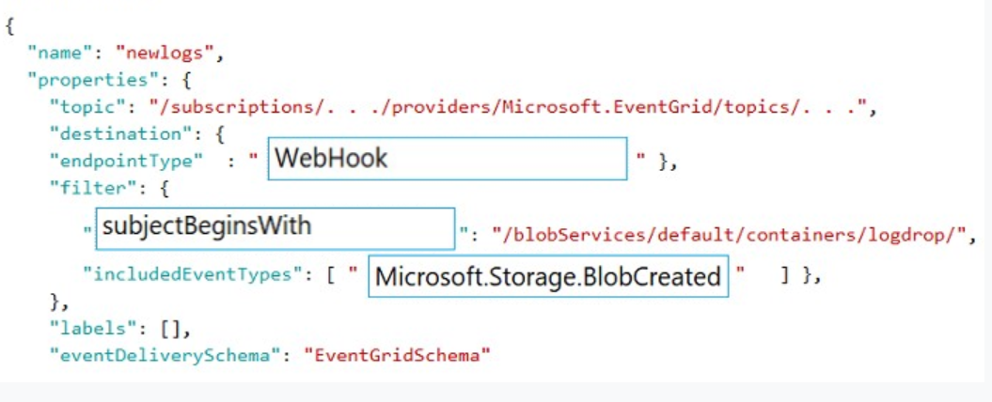

EventGrid

endpointType : WebHook
subjectBegingsWith : “/blobServices/default/containers/logdrop”
includedEventType : [“Microsoft.Storage.BlobCreated”]

You need to ensure that the solution can meet the scaling requirements for Policy Service.
an Application Insights metric

Policy service must use Application Insights to automatically scale with the number of policy actions that it is performing.

You need to implement telemetry for non-user actions.
How should you complete the Filter class?

Filter and preprocess telemetry in the Application Insights SDK

Filtering is a more basic approach to reducing traffic than sampling.
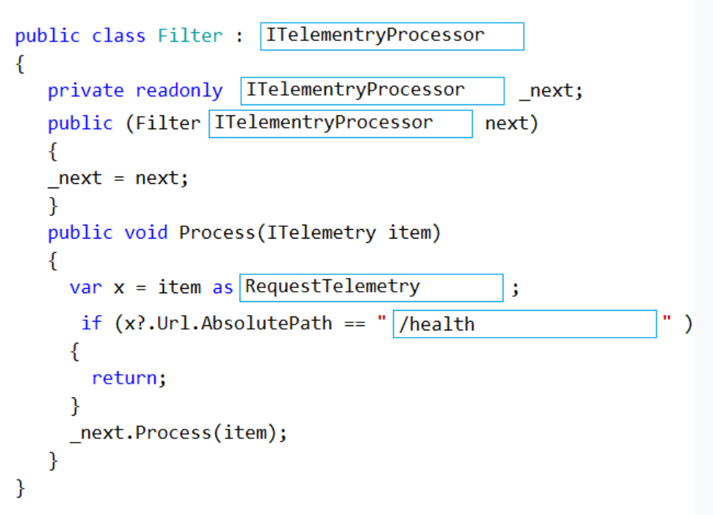

To create a filter, implement ITelemetryProcessor. This technique gives you more direct control over what is included or excluded from the telemetry stream.

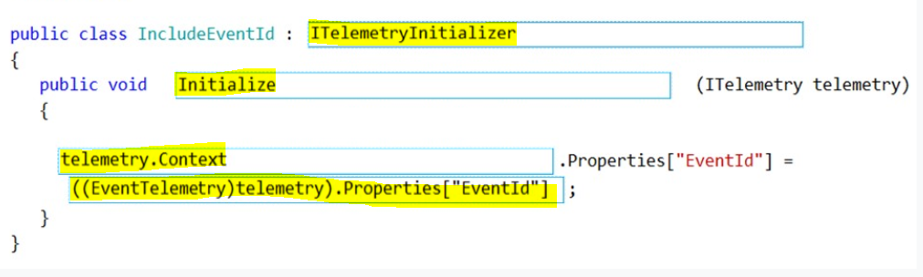

Use telemetry initializers to define global properties that are sent with all telemetry; and to override selected behavior of the standard telemetry modules.

You need to ensure receipt processing occurs correctly.
Use blob SnapshotTime to prevent concurrency problems

You can create a snapshot of a blob. A snapshot is a read-only version of a blob that's taken at a point in time. Once a snapshot has been created, it can be read, copied, or deleted, but not modified

You need to resolve the capacity issue.
Update the loop starting on line PC09 to process items in parallel

You need to resolve the log capacity issue.
Implement Application Insights Sampling

Developers report that the number of log message in the trace output for the processor is too high, resulting in lost log messages.
Sampling is a feature in Azure Application Insights. It is the recommended way to reduce telemetry traffic and storage, while preserving a statistically correct analysis of application data

You need to troubleshoot the order workflow.
Review the run history
Review the trigger history

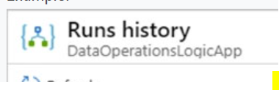
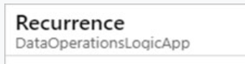

You need to update the order workflow to address the issue when calling the Printer API App.

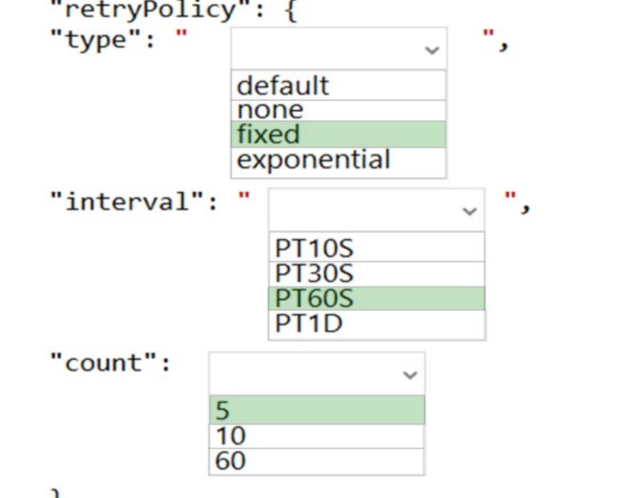

Create an integration account in Azure portal
Link the logic app to the integration account
Add parterns , schemas , certificates , maps and agreements
Create a custom connector for the Logic App

https://docs.microsoft.com/bs-latn-ba/azure/logic-apps/logic-apps-enterprise-integration-metadata

You need to support the requirements for the Shipping Logic App.
What should you use?

On-premises Data Gateway

Before you can connect to on-premises data sources from Azure Logic Apps, download and install the on-premises data gateway on a local computer. The gateway works as a bridge that provides quick data transfer and encryption between data sources on premises (not in the cloud) and your logic apps.

You need to correct the RequestUserApproval Function app error. (time out in 10 mins)
Update the function to be stateful by using Durable Functions to process the request payload.

az eventgrid event-subsciption create –source-resource-id $topicid –name $name –endpoint-type servicebusqueue –endpoint $endpoint

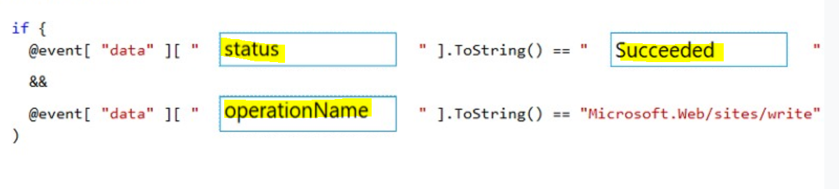
dataVersion is the schema version of the data object. The publisher defines the schema version.

All log files should be saved to a container named logdrop.
Logs must remain in the container for 15 days.
clint.WebApps.UpdateApplicationSetting

Azure Functions can run on either a Consumption Plan or a dedicated App Service Plan. If you run in a dedicated mode, you need to turn on the Always On setting for your Function App to run properly.

event.eventType == ‘RepositoryUpdated’
event.data.target.service === ‘contentanalysisservice’
event.imageCollection.contains(‘contosoimages’)

You need to deploy the CheckUserContent Azure Function. The solution must meet the security and cost requirements.

App Service plan

Build a new application image by using dockerfile
Create an alias of the image with the fully qualified path to the registry
Log in to the registry and push image

You need to access data from the user claim object in the e-commerce web app.
Update the e-commerce web app to read the HTTP request header values.

All Internal services must only be accessible from Internal Virtual Networks (VNets) : Private

The volume of agreements is expected to be in the millions. You need to store the user agreements.
Azure Event Hub

It can capture the streaming data into a file for processing and analysis.
It has the following characteristics:
✑ low latency
capable of receiving and processing millions of events per second
✑ at least once delivery

You need to implement the bindings for the CheckUserContent function.
How should you complete the code segment?

[BlogTrigger(“userContent/{name}”)] string content
[Blob(“userContent/{name}”,FileAccess.Write)] Stream output

You need to configure the Account Kind, Replication, and Storage tier options for the corporate website’s Azure Storage account.
Storage V2
Geo-redundant storage (GRS)
Cool

For .NET applications, the simplest way to work with a managed identity is through the Microsoft.Azure.Services.AppAuthentication package

Use AzureServiceTokenProvider to simplify requesting access tokens for your Azure clients, like the below examples:

var tp = new AzureServiceTokenProvider();
var t = new TokenCredential(await tp.GetAccessTokenAsync(“…”))
return new StorageCredentials(t)

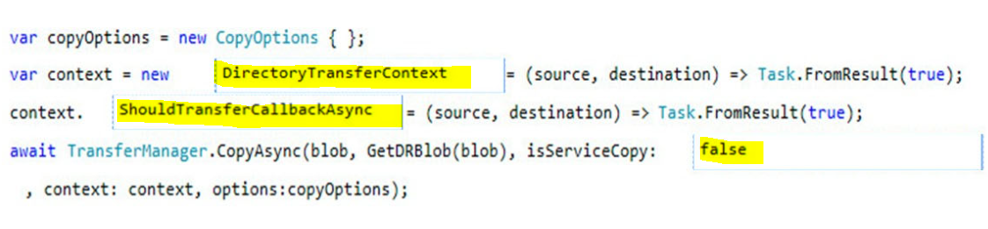

Consistency Level : Strong
API : SQL

You need to retrieve all order line items from Order.json and sort the data alphabetically by the city.

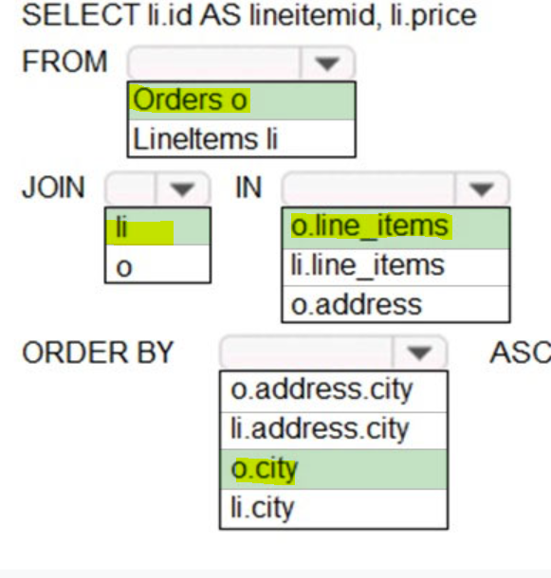

Mobile offline data sync

await todoTable.PullAsync("todoItems" + userid, syncTable.Where(u => u.UserId == userId));
To use incremental sync, your server must return meaningful updatedAt values.

You can clear the contents of the local store using IMobileServiceSyncTable.PurgeAsync.

